Zachary Allen
Module-7 City Functions and Unit Tests
City_functions.py
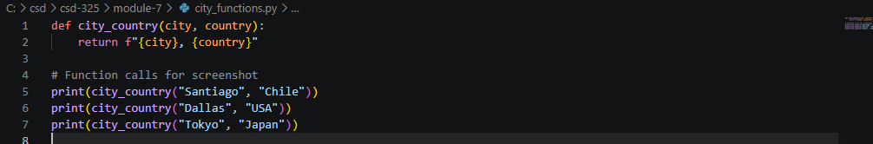
Test_cities.py
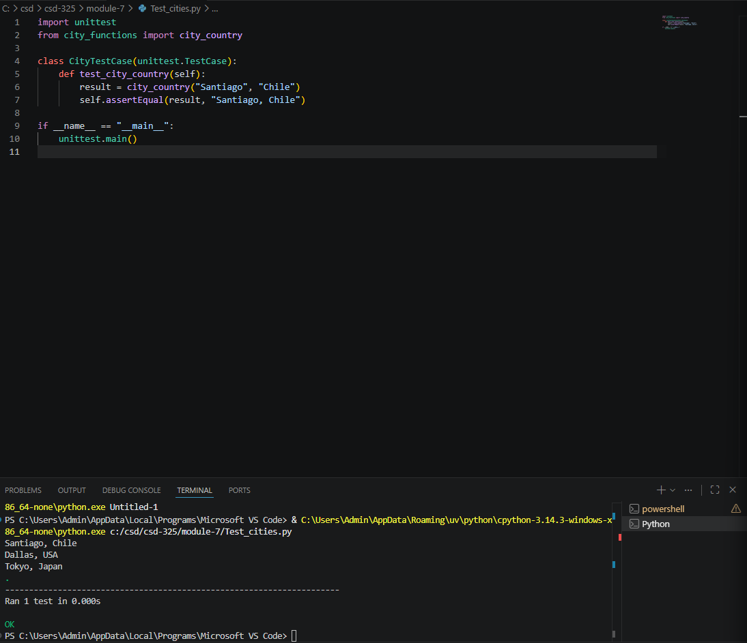
Failed Test
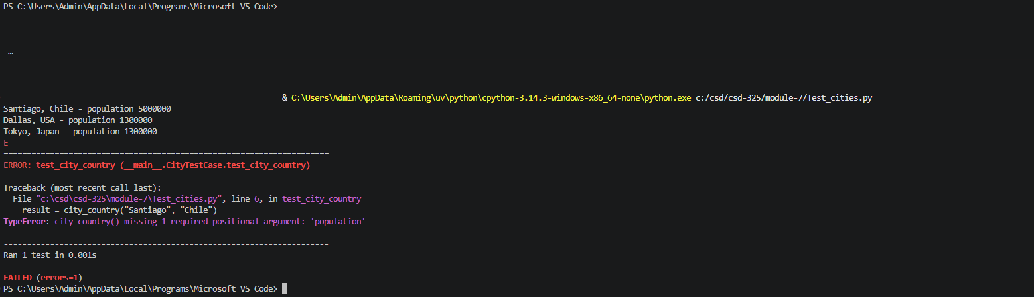
Pass test
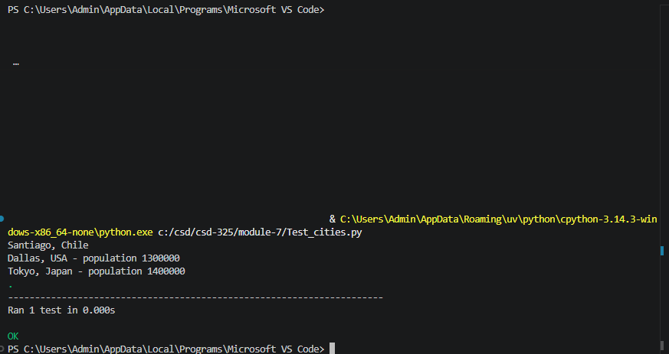

Language Parameter Fail
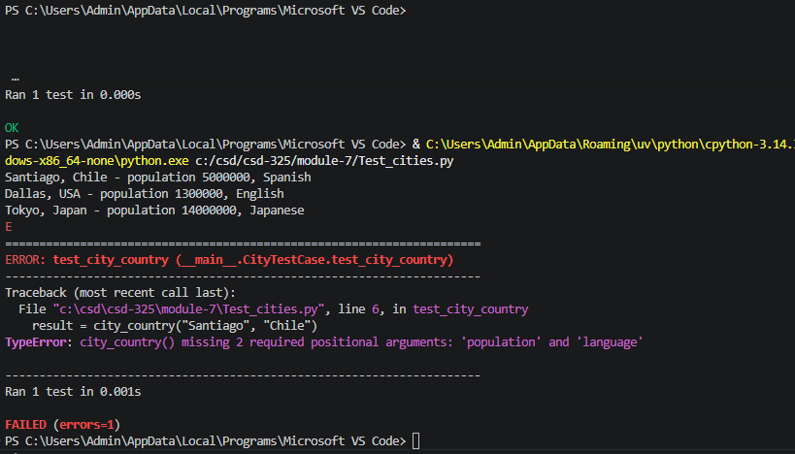
Pass test
